SITEWISE AI
AI-Assisted Satellite Image Land-Cover Analysis and Site Suitability Screening
B.Tech — Computer Science and Engineering (Artificial Intelligence & Machine Learning)
VIT-AP University
PROJECT REPORT
Team Members:
1. 24BCA8067
2. 24BCA7850
3.24BCA7708
4.24BCE7118

Academic Year: FALL SEMESTER 2026-2027
Declaration
We declare that the project titled “SiteWise AI” was developed as an academic project using the software, datasets, models, and implementation described in this report. The technical description and limitations are intended to represent the supplied implementation accurately.

Table of Contents
1. Abstract
2. Introduction
3. Problem Statement
4. Objectives
5. Literature Review
6. Dataset
7. Data Preprocessing
8. System Architecture
9. Model 1 — Land-Cover Classification
10. Model Training
11. Model Evaluation
12. Robustness and Reliability
13. Model 2 — Reliability Screening
14. Model 3 — Site Suitability Screening
15. Web Application
16. Technology Stack
17. Implementation
18. Results and Validation
19. Limitations
20. Future Scope
21. Conclusion
22. References
23. Appendix A — Class Mapping
24. Appendix B — Viva Preparation
25. Version Consistency Note

1. Abstract
SiteWise AI is an end-to-end web-based computer-vision system for satellite/aerial RGB image analysis. Its primary supervised task is ten-class land-use/land-cover classification using the EuroSAT RGB dataset and an EfficientNetB0 convolutional neural network trained through transfer learning and staged fine-tuning. The system accepts an uploaded image, derives eight deterministic RGB-based visual features, evaluates input reliability, and produces a project-defined site-suitability screening profile. The models are integrated through a Flask backend and JavaScript-based frontend.
A key scientific distinction is maintained throughout this report: EuroSAT provides supervised land-cover labels, not ground-truth labels for real-world development suitability. SiteWise AI is therefore an AI-assisted screening and academic demonstration system, not a planning-approval or professional site-selection tool.

2. Introduction
Satellite and aerial imagery provide compact visual representations of land surfaces and built environments. Automated image classification can assist in organizing and interpreting large collections of imagery. CNNs are effective for image tasks because they learn hierarchical spatial representations.
SiteWise AI extends classification into a decision-support workflow: it identifies land cover, exposes probability information, extracts additional visual signals, screens input reliability, and generates a project-defined recommendation profile.
The project combines deep learning, transfer learning, feature engineering, computer vision, Flask API development, frontend engineering, and deployment.

3. Problem Statement
Manual interpretation of satellite imagery can be time-consuming when many images must be reviewed. The project addresses the technical problem of automatically identifying land-cover categories from RGB imagery and using the resulting evidence to produce a transparent, project-defined site-use screening signal.

4. Objectives
- Build a supervised ten-class RGB land-cover classifier.
- Use EfficientNetB0 transfer learning and staged fine-tuning.
- Extract eight deterministic RGB-derived visual features.
- Develop a reliability gate using clean and synthetically degraded training imagery.
- Produce eight project-defined suitability scores and a ranked recommendation.
- Integrate the inference pipeline into Flask and a browser interface.
- Document limitations and avoid representing screening scores as planning approval.

5. Literature Review

5.1 Satellite Land-Cover Classification
EuroSAT is a Sentinel-2-based land-use/land-cover benchmark containing 27,000 labeled and geo-referenced samples across ten classes. The benchmark demonstrates the use of deep convolutional models for remote-sensing classification. [1]

5.2 CNNs
Convolutional neural networks learn local spatial patterns and combine them into higher-level representations, making them suitable for image classification.

5.3 Transfer Learning
Transfer learning reuses pretrained representations and adapts them to a target task. Keras recommends freezing the pretrained base initially, then fine-tuning with a low learning rate; BatchNormalization requires careful inference-mode handling during fine-tuning. [3]

5.4 EfficientNet
EfficientNet introduced compound scaling of network depth, width, and input resolution. EfficientNetB0 is a compact member of the family and is available with ImageNet-pretrained weights in Keras. [2][4]

5.5 Suitability Screening
Real site-suitability studies generally combine multiple geospatial and contextual variables such as roads, terrain, water, population, infrastructure, zoning, and environmental constraints. SiteWise AI does not contain real-world development-suitability labels; its suitability layer is therefore project-defined screening.

6. Dataset
The project uses tanganke/eurosat on Hugging Face for the RGB land-cover task. The supplied dataset card lists 21,600 training examples, 2,700 clean test examples, and seven 2,700-example corruption splits: contrast, Gaussian noise, impulse noise, JPEG compression, motion blur, pixelate, and spatter. The exact ten-class ordering is retained.
ID | Dataset label | SiteWise terminology
0 | Annual Crop | Annual Crop Land
1 | Forest | Forest
2 | Herbaceous Vegetation | Brushland / Shrubland
3 | Highway | Highway / Road
4 | Industrial | Industrial / Commercial
5 | Pasture | Pasture Land
6 | Permanent Crop | Permanent Crop Land
7 | Residential | Residential
8 | River | River
9 | Sea/Lake | Lake / Sea

The raw RGB samples are 64×64 thumbnails. The model resizes them to 224×224 for EfficientNetB0. Keras documentation states that EfficientNet includes input preprocessing and expects floating-point pixel values in the [0,255] range. [4]

7. Data Preprocessing

7.1 Image Representation
Uploaded imagery is converted to RGB before inference.

7.2 Augmentation
Training uses random horizontal/vertical flips, rotation, and zoom to expose the classifier to controlled spatial variation.

7.3 Resize
The 64×64 RGB representation is resized to 224×224 for EfficientNetB0.

7.4 Class Handling
The refined implementation validates the dataset's actual class names and preserves the ten indices without shuffling.

7.5 Visual Feature Engineering
Feature | Purpose
Mean red | Average normalized red-channel intensity.
Mean green | Average normalized green-channel intensity.
Mean blue | Average normalized blue-channel intensity.
Brightness | Average RGB intensity.
Vegetation ratio | Fraction of pixels satisfying a green-dominance rule.
Water ratio | Fraction of pixels satisfying a blue-dominance rule.
Built-up ratio | Fraction of pixels passing the project-defined bright-RGB threshold.
Road indicator | Fraction of bright, relatively neutral pixels that can resemble road surfaces.

These are visual heuristics, not professional remote-sensing segmentation or object-detection outputs.

8. System Architecture
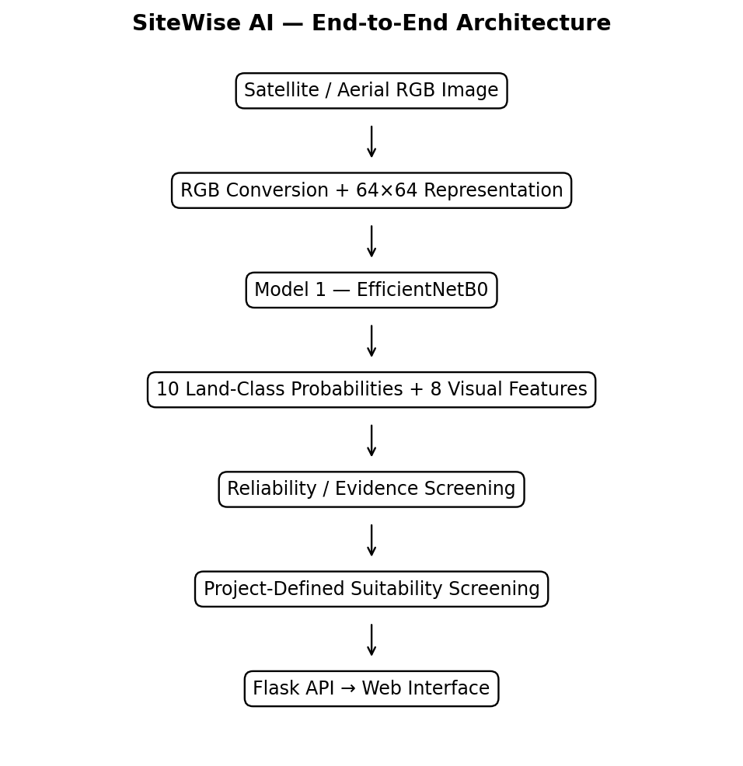
Figure 1. SiteWise AI end-to-end architecture.
The final production-candidate materials describe the system as satellite RGB land-cover classification plus reliability screening and explainable site screening.

9. Model 1 — Land-Cover Classification
Model 1 is the primary deep-learning component. It uses ImageNet-pretrained EfficientNetB0 with a task-specific ten-class output.
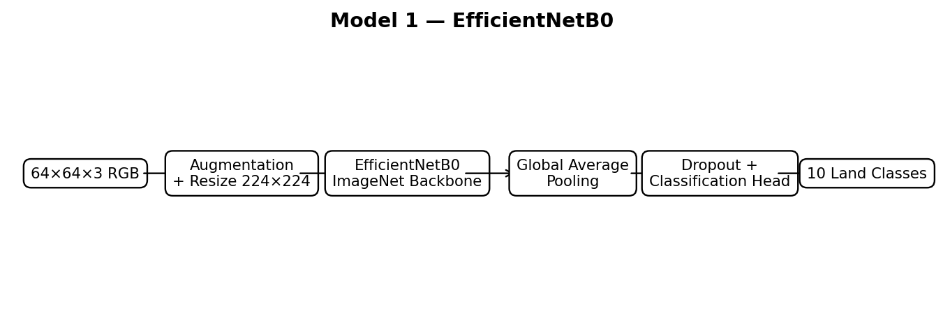
Figure 2. Model 1 — EfficientNetB0 transfer-learning architecture.
Stage | Implementation
Input | 64×64×3 RGB
Augmentation | Random flip, rotation, zoom during training
Resize | 224×224
Backbone | EfficientNetB0, ImageNet-pretrained, include_top=False
Aggregation | Global Average Pooling
Regularization | Dropout
Output | 10 land-cover classes

9.1 Transfer-Learning Strategy
The training workflow starts with a frozen pretrained backbone. A later phase fine-tunes approximately the last 40 layers, followed by a deeper phase exposing approximately the last 100 layers. BatchNormalization layers remain frozen during later fine-tuning.

9.2 Output Interpretation
Model 1 produces ten class probabilities. The maximum-probability class is the primary land-cover prediction. The order is fixed and is passed unchanged into downstream processing.

10. Model Training
The supplied materials contain an earlier baseline notebook and a later production-refined 54-cell training pipeline. This report treats the production-refined pipeline as the final technical reference.
Aspect | Final production-candidate description
Backbone | EfficientNetB0 with ImageNet-pretrained weights.
Fine-tuning | Staged, progressively deeper fine-tuning.
BatchNormalization | Kept frozen/in inference mode during later fine-tuning.
Regularization | Dropout and training augmentation.
Class handling | Training distribution is audited and class weights are prepared.
Confidence | Confidence, entropy, margin and calibration utilities are included.
Artifacts | Models, metadata, evaluation metrics and integrity checks are generated.

Exact executed numeric results such as final test accuracy and balanced accuracy are not embedded as executed values in the supplied notebook source, so this report does not invent them.

11. Model Evaluation
The refined pipeline evaluates Model 1 on a clean held-out test set using loss/accuracy, classification report, balanced accuracy, macro-F1, and a confusion matrix.
Metric / artifact | Status
Clean test accuracy | Computed by notebook; numeric execution output not present in supplied source.
Balanced accuracy | Computed by notebook; numeric execution output not present in supplied source.
Macro-F1 | Computed during detailed evaluation.
Confusion matrix | Generated and saved.
Training curves | Generated for staged Model 1 training.
Evaluation metrics JSON | Generated by the pipeline.

This preserves academic integrity by separating an evaluation procedure from a verified numerical result.

12. Robustness and Reliability
Corruption | What it tests
Contrast | Sensitivity to altered contrast.
Gaussian noise | Sensitivity to additive noise.
Impulse noise | Sensitivity to isolated pixel corruption.
JPEG compression | Sensitivity to lossy compression.
Motion blur | Sensitivity to blur-like degradation.
Pixelate | Sensitivity to reduced spatial detail.
Spatter | Sensitivity to visual contamination artifacts.

Model 1 is evaluated across all seven supplied corruption splits. The pipeline also computes entropy, maximum confidence, and top-1/top-2 probability margin.

13. Model 2 — Reliability Screening
In the final production-candidate pipeline, Model 2 is not the earlier bank-versus-college suitability model. It is a CNN-based reliability gate intended to estimate whether an input resembles clean/reliable imagery or degraded imagery.
Reliability training data are constructed from the training split only. Synthetic transformations include noise, contrast changes, blur-like degradation, JPEG degradation, and clean examples. The reliability model uses convolutional layers, global average pooling, dropout, and a sigmoid output, trained with binary cross-entropy and evaluated using binary accuracy and AUC.
The final inference gate requires classification confidence ≥ 0.70 and reliability ≥ 0.55. These are project thresholds, not universal statistical guarantees. The model card explicitly states that Model 2 is not a universal out-of-distribution detector.

14. Model 3 — Site Suitability Screening
The final production-candidate implementation describes Model 3 as an explainable, project-defined suitability engine rather than a scientifically validated real-world development predictor.
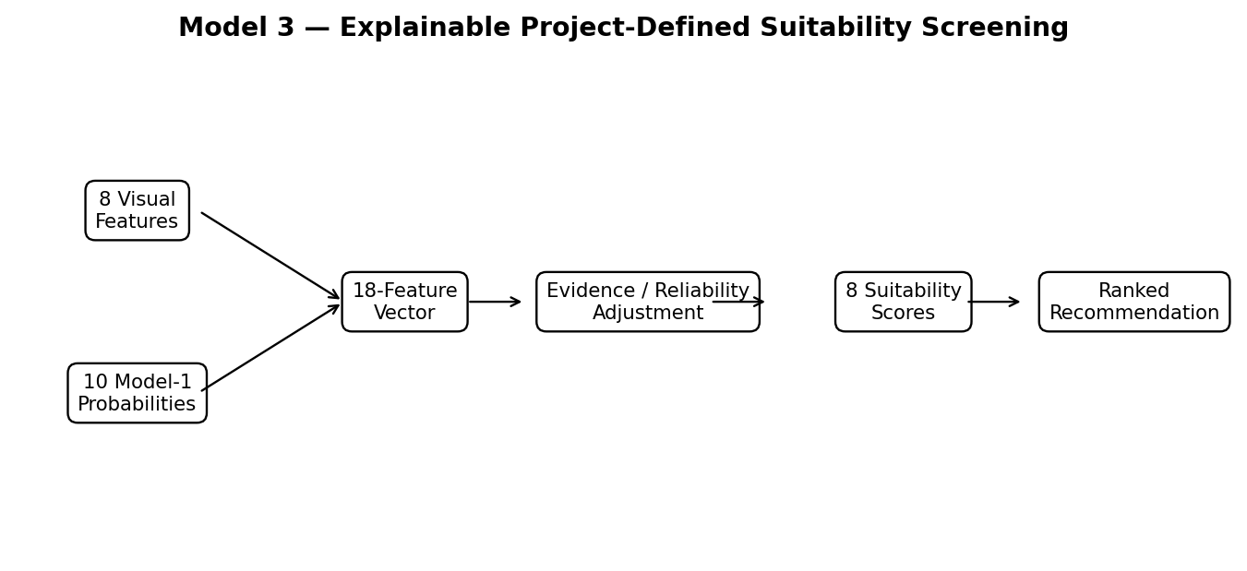
Figure 3. Model 3 — combined evidence and project-defined suitability screening.
The recommendation stage combines eight visual features with the ten Model 1 probabilities, producing an 18-dimensional representation. Project-defined scoring functions generate eight suitability scores, and an evidence-quality term derived from classification/reliability information adjusts the screening result.
Index | Recommendation
1 | Residential Development
2 | Commercial Development
3 | Industrial Development
4 | Educational Development
5 | Healthcare Development
6 | Agricultural Use
7 | Transportation Infrastructure
8 | Green / Conservation

The scores are not probabilities. The highest adjusted score is used for the ranked recommendation. The system should be described as answering which project-defined category receives the strongest screening score under the available visual evidence, not which development is legally or economically approved.

15. Web Application
The system is integrated into Flask with an HTML/CSS/JavaScript frontend. The browser sends an image using FormData to POST /predict.
Route / component | Function
/ | Serves the main interface.
/health | Reports model/scaler readiness.
/api/project-info | Provides project/model information.
/predict | Receives an image and returns inference JSON.
Frontend JavaScript | Upload, preview, analysis request, result rendering, reset and presentation/viva interactions.

The backend validates the upload, converts it to RGB, runs inference, and returns land class, confidence, reliability, recommendation, recommendation score, evidence quality and probabilities.

16. Technology Stack
Technology | Role
Python | Training and backend implementation.
TensorFlow / Keras | Deep learning and inference.
EfficientNetB0 | Primary land-cover CNN.
NumPy | Numerical computation.
Pillow | Image loading and RGB conversion.
scikit-learn | Scaling, splitting and metrics.
joblib | Serialization of preprocessing artifacts.
Flask | Web backend/API.
HTML / CSS / JavaScript | Frontend.
Gunicorn | Production WSGI serving.

The supplied requirements pin Flask 3.1.2, NumPy 2.1.3, Pillow 11.3.0, joblib 1.5.2, scikit-learn 1.7.2 and TensorFlow 2.20.0.

17. Implementation

17.1 Inference Sequence
- User uploads image.
- Browser sends image to POST /predict.
- Flask validates and converts the image to RGB.
- Model 1 produces ten land-class probabilities.
- Maximum probability becomes the land-class prediction.
- Reliability gate estimates input reliability.
- Eight visual features are extracted.
- Eight features + ten probabilities form the combined representation.
- Suitability engine produces eight project-defined scores.
- Evidence quality adjusts the screening result.
- Top recommendation is selected.
- JSON is returned and rendered by the frontend.

17.2 Deployment
The intended deployment pattern is GitHub → Render → Gunicorn → Flask → TensorFlow model artifacts → browser. The production start command supplied with the project is gunicorn --workers 1 --threads 4 --timeout 120 app:app.

18. Results and Validation
- Dataset integrity validation.
- Exact class-mapping validation.
- Clean test evaluation.
- Seven-way robustness evaluation.
- Reliability-gate validation.
- Artifact existence and non-empty checks.
- Fresh-load inference smoke test.
- Production model-card generation.
The production-refined notebook's final validation summary explicitly includes these checks.

18.1 Historical Model 3 Artifact Metrics
An earlier project artifact reports Model 3 test MSE = 0.000075, test MAE = 0.004929, and Top-1 Recommendation Agreement = 98.67%. These figures describe agreement with project-defined targets on held-out data, not real-world site-selection accuracy. Because the later production candidate describes Model 3 as an explainable screening engine, these values are treated as historical project-artifact metrics rather than final externally validated suitability performance.

19. Limitations
- EuroSAT is a land-cover dataset, not a zoning/development approval dataset.
- RGB-derived vegetation, water, built-up and road features are heuristic indicators.
- Model 2 is a reliability/corruption gate, not a universal OOD detector.
- Softmax confidence is not automatically a calibrated probability of correctness.
- Model 3 scores are project-defined screening scores, not probabilities or planning approval.
- Real site planning requires zoning, terrain, roads, utilities, flood risk, soil, ownership, environmental and regulatory information.
- The supplied materials contain multiple project versions; the later production-refined implementation is treated as final.

20. Future Scope
- Multispectral Sentinel-2 analysis.
- GIS integration.
- Road, elevation and slope layers.
- Zoning and regulatory constraints.
- Population, utilities and infrastructure data.
- Flood, soil and environmental constraints.
- Real-world suitability labels and expert annotation.
- Stronger OOD detection and calibrated uncertainty.
- Semantic segmentation.
- Geospatial validation and explainable AI.

21. Conclusion
SiteWise AI demonstrates an end-to-end AI application connecting supervised satellite-image classification to an explainable screening workflow and deployed web interface. EfficientNetB0 provides the primary land-cover classifier; reliability screening and RGB-derived visual features provide additional evidence; and the project-defined suitability engine produces a ranked recommendation.
The project is strongest when its scope is stated precisely: EuroSAT supports land-cover classification, while the suitability layer is a project-defined screening mechanism. Future versions can make the recommendation stage scientifically stronger through real geospatial variables and independently labeled development outcomes.

22. References
[1] P. Helber, B. Bischke, A. Dengel, and D. Borth, “EuroSAT: A Novel Dataset and Deep Learning Benchmark for Land Use and Land Cover Classification,” IEEE Journal of Selected Topics in Applied Earth Observations and Remote Sensing, 2019.
[2] M. Tan and Q. V. Le, “EfficientNet: Rethinking Model Scaling for Convolutional Neural Networks,” ICML, 2019.
[3] Keras Documentation, “Transfer learning & fine-tuning,” Keras Developer Guides.
[4] Keras Documentation, “EfficientNet models,” Keras Applications documentation.
[5] tanganke/eurosat, Hugging Face Datasets, EuroSAT dataset card.

23. Appendix A — Exact Class Mapping
ID | EuroSAT / dataset | SiteWise
0 | Annual Crop | Annual Crop Land
1 | Forest | Forest
2 | Herbaceous Vegetation | Brushland / Shrubland
3 | Highway | Highway / Road
4 | Industrial | Industrial / Commercial
5 | Pasture | Pasture Land
6 | Permanent Crop | Permanent Crop Land
7 | Residential | Residential
8 | River | River
9 | Sea/Lake | Lake / Sea

24. Appendix B — Viva Preparation
Question | Answer
What is SiteWise AI? | An end-to-end web application that classifies satellite RGB imagery into ten EuroSAT land-cover classes and generates project-defined site-screening scores.
Why EfficientNetB0? | It provides a strong pretrained CNN representation with comparatively modest computational cost and supports transfer learning.
Why transfer learning? | It reuses learned visual representations instead of learning all low-level features from scratch.
What is EuroSAT? | A Sentinel-2-based land-use/land-cover benchmark with ten labeled classes.
Why 64×64? | The EuroSAT RGB samples used by the project are 64×64 thumbnails.
Why 224×224? | 224×224 is the standard EfficientNetB0 input resolution in Keras.
What does Model 1 predict? | Ten land-cover probabilities in a fixed class order.
What are the eight visual features? | Mean R, mean G, mean B, brightness, vegetation, water, built-up and road indicator.
Why combine features with probabilities? | The recommendation stage uses both semantic class evidence and additional RGB-derived context.
What is Model 2? | A CNN reliability gate trained to distinguish clean/reliable imagery from synthetically degraded imagery.
Is Model 2 universal OOD detection? | No.
What is Model 3? | An explainable project-defined suitability screening engine in the final production candidate.
Are suitability scores probabilities? | No.
Does EuroSAT contain development suitability labels? | No.
Can SiteWise approve a construction site? | No. Professional planning and engineering assessment is required.
What does the 70% threshold mean? | The maximum land-class probability must reach at least 0.70 for the input to pass the confidence gate.
What is the reliability threshold? | 0.55 in the final production-candidate inference gate.
How does the browser communicate with the model? | JavaScript sends the image to Flask at POST /predict and receives JSON.
What is the main limitation? | The suitability stage is not trained on real-world development outcomes.
What is the main future improvement? | Integrate real geospatial variables and independently labeled suitability outcomes.

25. Version Consistency Note
The supplied materials contain multiple generations of SiteWise AI. Earlier artifacts describe Model 3 as a dense neural network trained against project-defined suitability targets and report historical MSE/MAE/Top-1 agreement. The later production-refined 54-cell notebook explicitly describes Model 2 as a CNN reliability gate and Model 3 as an explainable project-defined suitability engine. This report follows the later production-refined implementation as the final technical reference and treats the earlier metrics as historical project-artifact information.
END OF REPORT

